**LAB FILE**

**DATA WAREHOUSING AND DATA MINING LAB**

**(CIE‐425P)**

Student Name: Lakshay Sharma

Roll No: 02396402721

Semester: 7th

Group: 7-CSE-AIML-II-C

Faculty name: Garima Gupta



Department Of Computer Science & Engineering

Maharaja Agrasen Institute of Technology, PSP area, Sector – 22, Rohini,

New Delhi – 110085

(Affiliated to Guru Gobind Singh Indraprastha University, New Delhi)

**2024**



## MAHARAJA AGRASEN INSTITUTE OF TECHNOLOGY

**VISION**

To nurture young minds in a learning environment of high academic value and imbibe spiritual and ethical values with technological and management competence.

## MISSION

The Institute shall endeavour to incorporate the following basic missions in the teaching methodology:

**Engineering Hardware – Software Symbiosis**

Practical exercises in all Engineering and Management disciplines shall be carried out by Hardware equipment as well as the related software enabling deeper understanding of basic concepts and

encouraging inquisitive nature.

**Life – Long Learning**

The Institute strives to match technological advancements and encourage students to keep updating their knowledge for enhancing their skills and inculcating their habit of continuous learning.

**Liberalization and Globalization**

The Institute endeavors to enhance technical and management skills of students so that they are intellectually capable and competent professionals with Industrial Aptitude to face the challenges of globalization.

**Diversification**

The Engineering, Technology and Management disciplines have diverse fields of studies with different attributes. The aim is to create a synergy of the above attributes by encouraging analytical thinking.

**Digitization of Learning Processes**

The Institute provides seamless opportunities for innovative learning in all Engineering and Management disciplines through digitization of learning processes using analysis, synthesis, simulation, graphics,

tutorials and related tools to create a platform for multi-disciplinary approach.

**Entrepreneurship**

The Institute strives to develop potential Engineers and Managers by enhancing their skills and research capabilities so that they become successful entrepreneurs and responsible citizens.



## MAHARAJA AGRASEN INSTITUTE OF TECHNOLOGY

**COMPUTER SCIENCE & ENGINEERING DEPARTMENT**

# VISION

“To be centre of excellence in education, research and technology transfer in the field of computer engineering and promote entrepreneurship and ethical values.”

# MISSION

“To foster an open, multidisciplinary and highly collaborative research environment to produce world-class engineers capable of providing innovative solutions to real life problems and fulfil societal needs.”

Department of Computer Science and Engineering Rubrics for Lab Assessment

|  |  |  |  |  |  |
| --- | --- | --- | --- | --- | --- |
| **Rubrics** | | **0** | **1** | **2** | **3** |
| **Missing** | **Inadequate** | **Needs Improvement** | **Adequate** |
| R1 | Is able to identify the problem to be solved and define the objectives of the experiment. | No mention is made of the problem to be solved. | An attempt is made to identify the problem to be solved but it is described in a confusing manner, objectives are not relevant, objectives contain technical/ conceptual errors or objectives are not measurable. | The problem to be solved is described but there are minor omissions or vague details. Objectives are conceptually correct and measurable but may be incomplete in scope or have linguistic errors. | The problem to be solved is clearly stated. Objectives are complete, specific, concise, and measurable. They are written using correct technical terminology and are free from linguistic errors. |
| R2 | Is able to design a reliable experiment that solves the problem. | The experiment does not solve the problem. | The experiment attempts to solve the problem but due to the nature of the design the data will not lead to a reliable solution. | The experiment attempts to solve the problem but due to the nature of the design there is a moderate chance the data will not lead to a reliable  solution. | The experiment solves the problem and has a high likelihood of producing data that will lead to a reliable solution. |
| R3 | Is able to communicate the details of an experimental procedure clearly and completely. | Diagrams are missing and/or experimental procedure is missing or extremely vague. | Diagrams are present but unclear and/or experimental procedure is present but important details are missing. | Diagrams and/or experimental procedure are present but with minor omissions or vague details. | Diagrams and/or experimental procedure are clear and complete. |
| R4 | Is able to record and represent data in a meaningful way. | Data are either absent or incomprehensible. | Some important data are absent or incomprehensible. | All important data are present, but recorded in a way that requires some effort to comprehend. | All important data are present, organized and recorded clearly. |
| R5 | Is able to make a judgment about the results of the experiment. | No discussion is presented about the results of the experiment . | A judgment is made about the results, but it is not reasonable or coherent. | An acceptable judgment is made about the result, but the reasoning is flawed or incomplete. | An acceptable judgment is made about the result, with clear reasoning. The effects of assumptions and experimental uncertainties are considered. |

# PRACTICAL RECORD

**PAPER CODE : CIE‐425P**

Name of Student : Lakshay Sharma

University roll : 02396402721

Semester : 7th (4th year)

Group : 7-CSE-AIML-II-C

## PRACTICAL DETAILS

|  |  |  |  |  |  |  |  |  |  |  |
| --- | --- | --- | --- | --- | --- | --- | --- | --- | --- | --- |
| **Exp. no** | **Experiment Name** | **Date of performance** | **Date of checking** | **R1 (3)** | **R2 (3)** | **R3 (3)** | **R4 (3)** | **R5 (3)** | **Total Marks (15)** | **Signature** |
| 1. | Study of ETL Process and its Tools |  |  |  |  |  |  |  |  |  |
| 2. | Program for Data Warehouse Cleansing to Input Inconsistent Names from Users and Format Them. |  |  |  |  |  |  |  |  |  |
| 3. | Program for Data Warehouse Cleansing to Remove Redundancy in Data |  |  |  |  |  |  |  |  |  |
| 4. | Introduction to WEKA Tool |  |  |  |  |  |  |  |  |  |
| 5. | Implementation of Classification Technique on ARFF Files using WEKA |  |  |  |  |  |  |  |  |  |
| 6. | Implementation of Clustering Technique on ARFF Files using WEKA |  |  |  |  |  |  |  |  |  |

|  |  |  |  |  |  |  |  |  |  |  |
| --- | --- | --- | --- | --- | --- | --- | --- | --- | --- | --- |
| **Exp. no** | **Experiment Name** | **Date of Performance** | **Date of checking** | **R1 (3)** | **R2 (3)** | **R3 (3)** | **R4 (3)** | **R5 (3)** | **Total Marks (15)** | **Signature** |
| 7. | Implementation of Association Rule Technique on ARFF Files using WEKA |  |  |  |  |  |  |  |  |  |
| 8. | Implementation of Visualization Technique on ARFF Files using WEKA |  |  |  |  |  |  |  |  |  |
| 9. | Perform Data Similarity Measure (Euclidean, Manhattan Distance). |  |  |  |  |  |  |  |  |  |
| 10. | Perform Apriori algorithm mine frequent item-sets |  |  |  |  |  |  |  |  |  |
| 11. | Develop different clustering algorithms like K-Means, KMedoids Algorithm, Partitioning Algorithm and Hierarchical |  |  |  |  |  |  |  |  |  |
| 12. | Apply Validity Measures to evaluate the quality of Data |  |  |  |  |  |  |  |  |  |

**EXPERIMENT - 1**

**AIM:** Study of ETL Process and its Tools

**THEORY:**

ETL stands for Extract, Transform, Load. It is a process in data warehousing responsible for pulling data from multiple sources, cleaning and transforming it, and then loading it into a target database. The ETL process has three stages:

1. **Extraction**: Data is pulled from different sources like relational databases, flat files, APIs, etc.
2. **Transformation**: This stage involves cleaning, filtering, and transforming data into a proper format suitable for loading into the target database.
3. **Loading**: The final step, where the transformed data is loaded into the target database, typically a data warehouse.

Popular ETL tools include **Informatica PowerCenter**, **Apache Nifi**, **Talend**, and **Microsoft SSIS**.

**Importance of ETL in Data Warehousing:**

* **Centralized Data**: The ETL process brings data from various sources into a single repository, allowing for comprehensive analysis.
* **Data Consistency**: ETL ensures that data is cleaned and standardized, providing accurate and reliable insights.
* **Automation**: Modern ETL tools automate repetitive data tasks, reducing human errors and saving time.

**Informatica PowerCenter**:

* A highly popular ETL tool used by enterprises for building data warehouses. It offers capabilities for data integration, transformation, and data quality management.
* Supports various data formats, including relational databases, flat files, and cloud platforms.

**Apache Nifi**:

* An open-source tool designed for data flow automation. Apache Nifi is highly scalable and suitable for real-time data extraction, transformation, and loading.
* It excels in **real-time data ingestion** and offers a user-friendly GUI for designing data flows.

**EXPERIMENT - 2**

**AIM:** Program for Data Warehouse Cleansing to Input Inconsistent Names from Users and Format Them.

**THEORY:**

Data cleansing involves identifying and correcting errors, inconsistencies, or duplicates in data sets. It ensures that the data is accurate, reliable, and formatted correctly for effective data analysis.

**SOURCE CODE:**

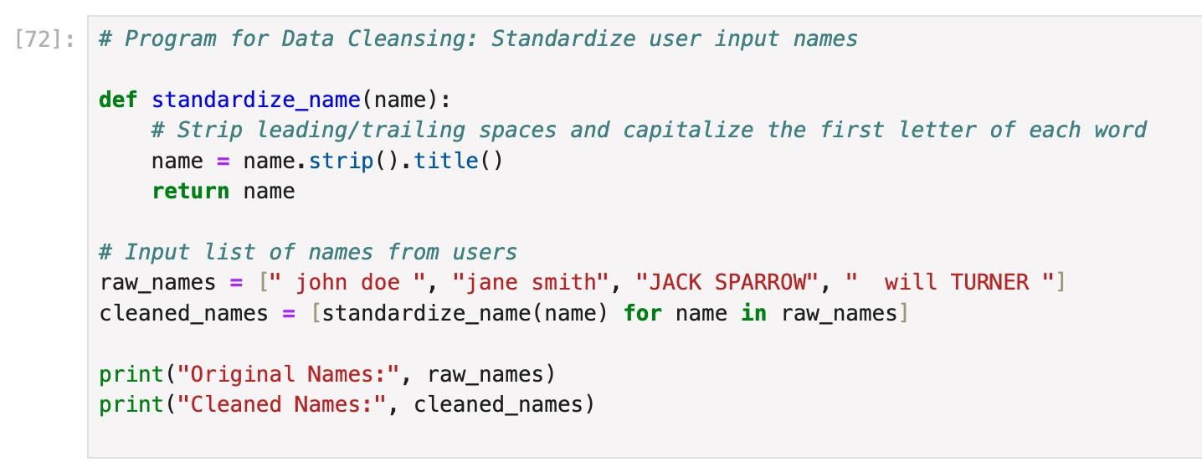

**OUTPUT:**



**EXPERIMENT - 3**

**AIM:** Program for Data Warehouse Cleansing to Remove Redundancy in Data

**THEORY:**

Removing redundancy in data means eliminating duplicate or irrelevant data from the dataset to ensure integrity and consistency. **Redundancy in data** refers to the presence of duplicate, irrelevant, or repetitive information within a dataset, which can lead to inefficiencies in data storage and analysis. Removing redundancy is a key step in ensuring **data integrity, consistency**, and **efficient use of resources**.

**SOURCE CODE:**

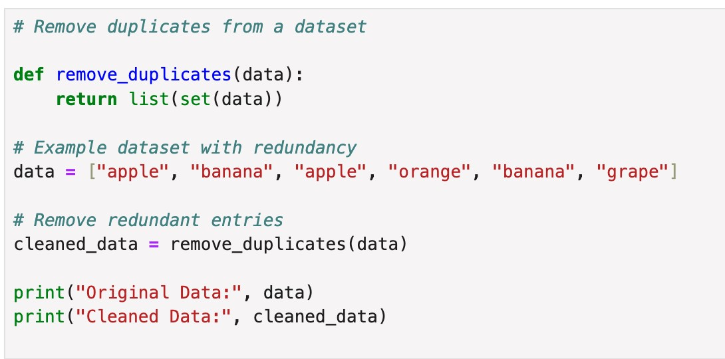

**OUTPUT:**



**EXPERIMENT - 4**

**AIM:** Introduction to WEKA Tool

**THEORY:**

WEKA (Waikato Environment for Knowledge Analysis) is an open-source machine learning software that contains a collection of tools for data pre-processing, classification, regression, clustering, and association rule mining. It allows easy implementation of machine learning algorithms on ARFF files (Attribute-Relation File Format).

**Key Features of WEKA**:

* GUI interface for data exploration and modeling.
* Supports various file types, including ARFF, CSV, and more.
* Provides access to well-known algorithms like decision trees, k-means, and SVM.

**Key Features of WEKA:**

1. **Graphical User Interface (GUI)**:
   1. WEKA comes with a user-friendly graphical interface, making it easy for users with minimal coding experience to load data, preprocess it, apply machine learning algorithms, and evaluate results.

○ The GUI allows for a drag-and-drop interface to design workflows for data preprocessing, transformation, and analysis.

1. **Extensive Algorithm Library**:
   * WEKA offers a variety of machine learning algorithms for:

* **Classification** (e.g., Decision Trees, Naive Bayes, Support Vector Machines),
  + - * **Regression** (e.g., Linear Regression),
      * **Clustering** (e.g., k-Means, DBSCAN),
      * **Association Rule Mining** (e.g., Apriori algorithm).

○ The algorithms can be easily applied to datasets with a few clicks, and users can adjust the parameters of the algorithms for optimization.

1. **Data Preprocessing Tools**:
   1. WEKA includes many tools for data preprocessing, such as handling missing values, normalizing data, attribute selection, and discretization.

○ Users can filter and transform datasets to make them ready for machine learning models, ensuring high data quality before analysis.

1. **Support for ARFF Files**:
   1. WEKA’s native file format is **ARFF (Attribute-Relation File Format)**, which is a simple text format that describes datasets in terms of attributes and their values.

○ It also supports other file formats such as **CSV**, **JSON**, and even connections to databases through JDBC, making it versatile for various data sources.

**EXPERIMENT - 5**

**AIM:** Implementation of Classification Technique on ARFF Files using WEKA

**THEORY:**

Classification is a supervised learning method in which an algorithm is trained to predict the categorical label of new data based on the input features. WEKA allows applying various classification algorithms such as J48 Decision Tree, Naive Bayes, and SVM on datasets.

**Steps for Implementing Classification in WEKA:**

1. Open WEKA and load the dataset (ARFF file).
2. Choose the Classification option.
3. Select a classifier (e.g., J48 Decision Tree).
4. Set parameters and run the classifier.
5. Analyze the output to understand the model's accuracy and confusion matrix.

**SOURCE CODE:**

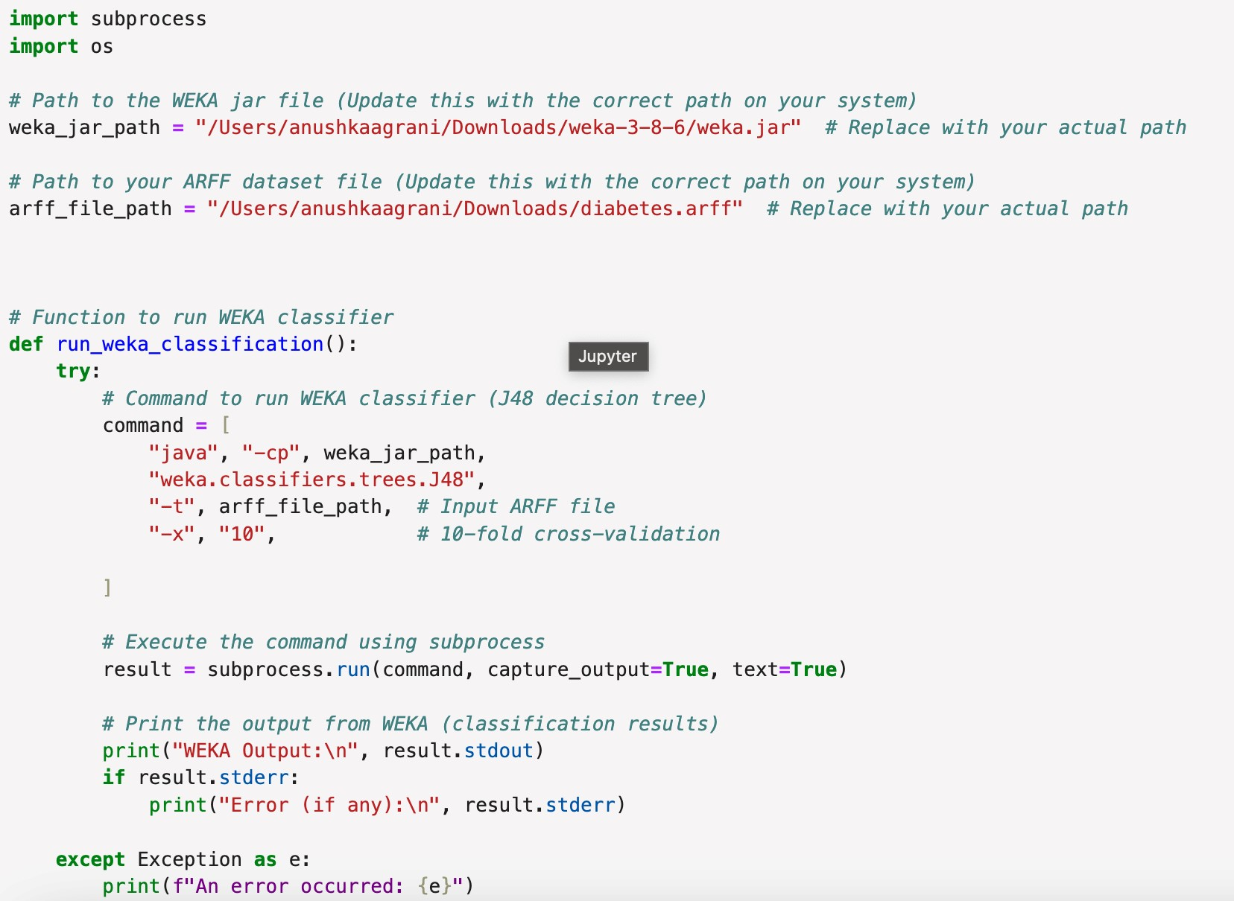

**OUTPUT:**

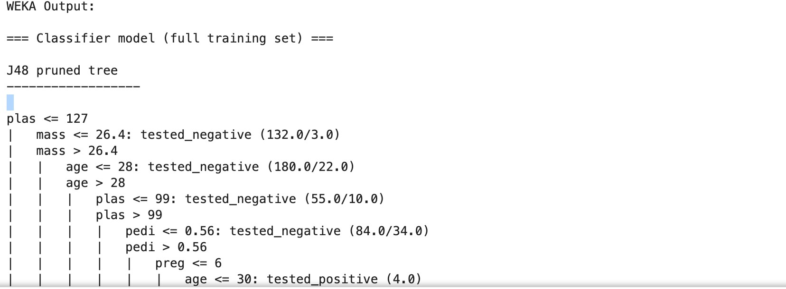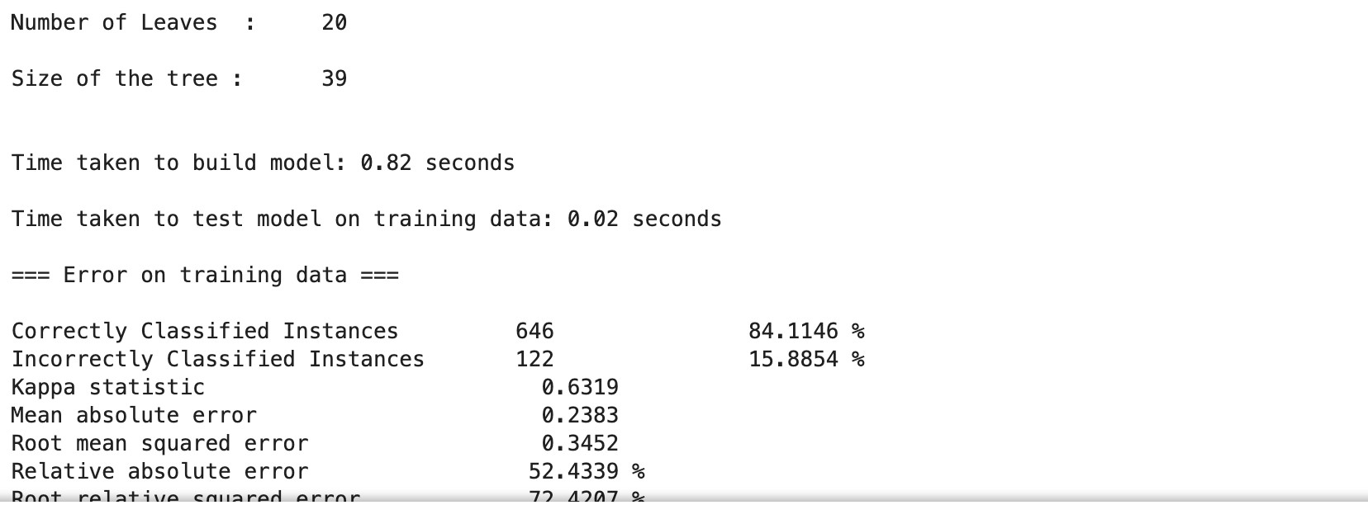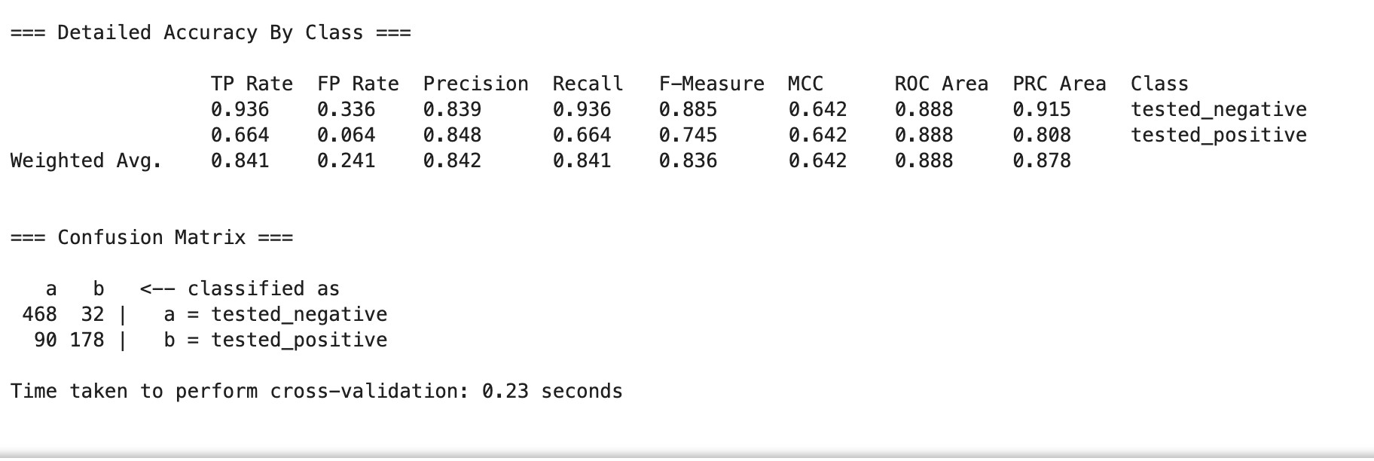

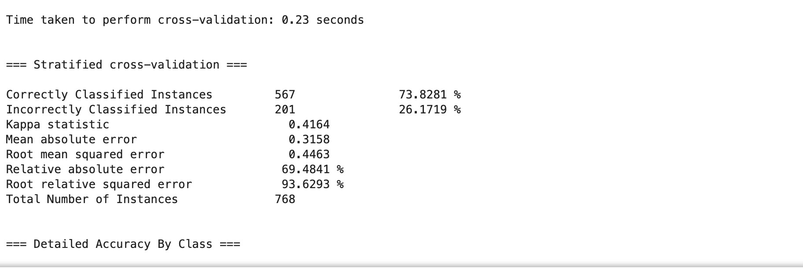

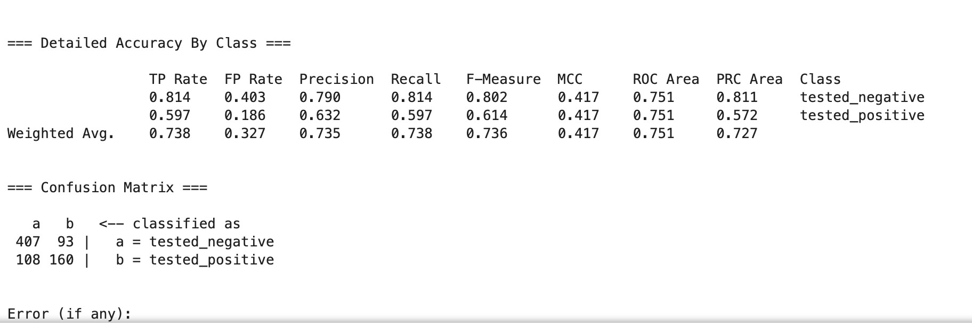

**EXPERIMENT - 6**

**AIM:** Implementation of Clustering Technique on ARFF Files using WEKA.

**THEORY:**

Clustering is an unsupervised machine learning technique that groups similar data points together based on their features, without using predefined labels. In the context of WEKA, an open-source tool for data mining, clustering algorithms such as **SimpleKMeans** can be applied to datasets stored in ARFF (Attribute-Relation File Format). The **K-Means** algorithm partitions the data into a predefined number of clusters (k), minimizing the variance within each cluster. WEKA provides a simple way to perform clustering by loading ARFF files, selecting the algorithm, configuring parameters like the number of clusters, and visualizing the results. This approach is commonly used for pattern recognition, market segmentation, and anomaly detection.

**SOURCE CODE:**

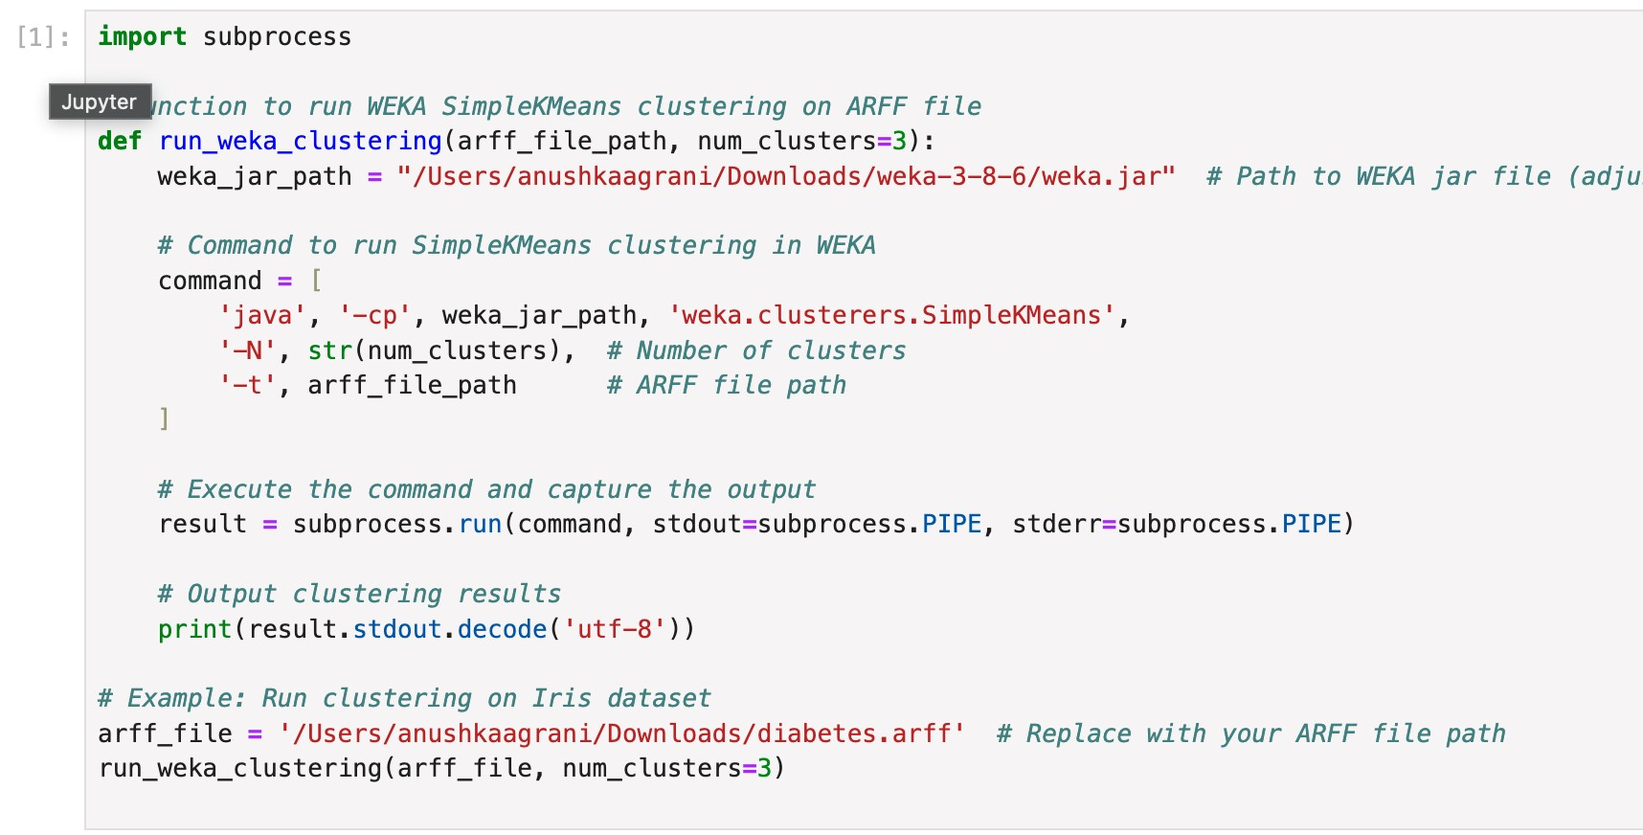

**OUTPUT:**

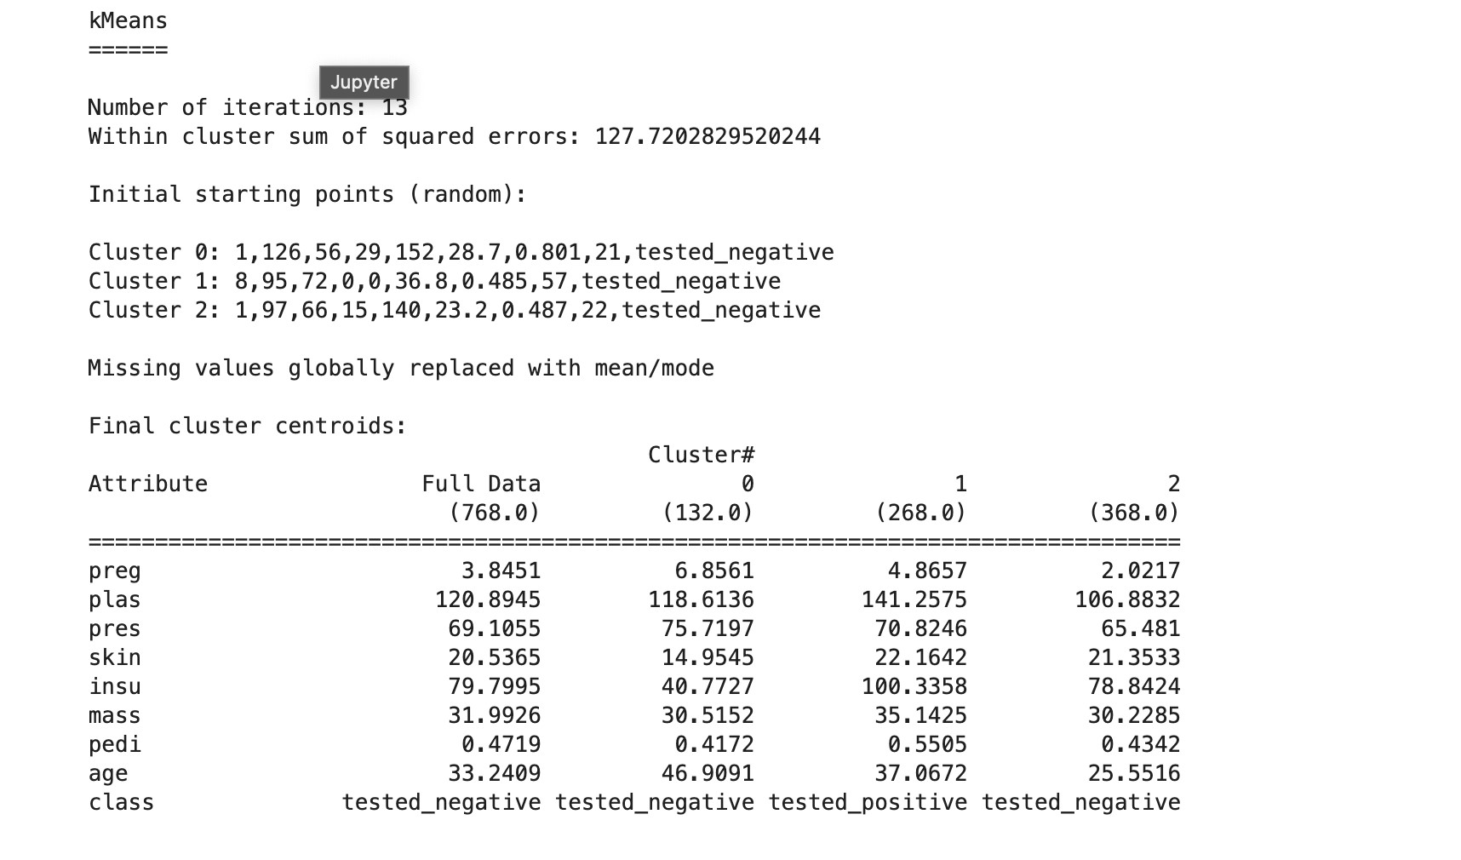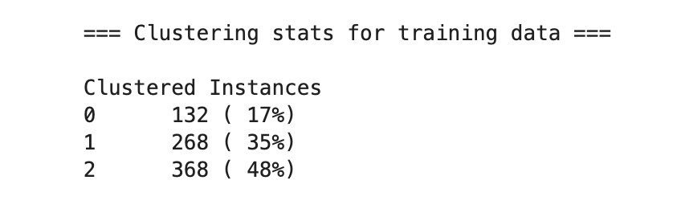

**EXPERIMENT - 7**

**AIM:** Implementation of Association Rule Technique on ARFF Files using WEKA

**THEORY:**

Association rule mining is a technique used to discover interesting relationships, or associations, between variables in large datasets. This is commonly used in market basket analysis to identify sets of items that frequently co-occur. An example of an association rule might be, "If a customer buys bread, they are also likely to buy butter." In WEKA, association rule mining is implemented using algorithms like Apriori, which discovers frequent itemsets and generates association rules based on user-defined thresholds for minimum support and confidence. The rules extracted from the dataset help in understanding hidden patterns and relationships that can support decision-making in fields such as retail, e-commerce, and recommendation systems.

**SOURCE CODE:**

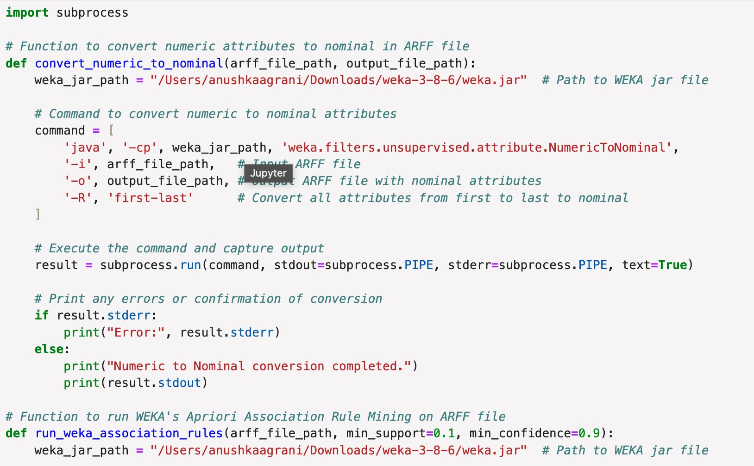

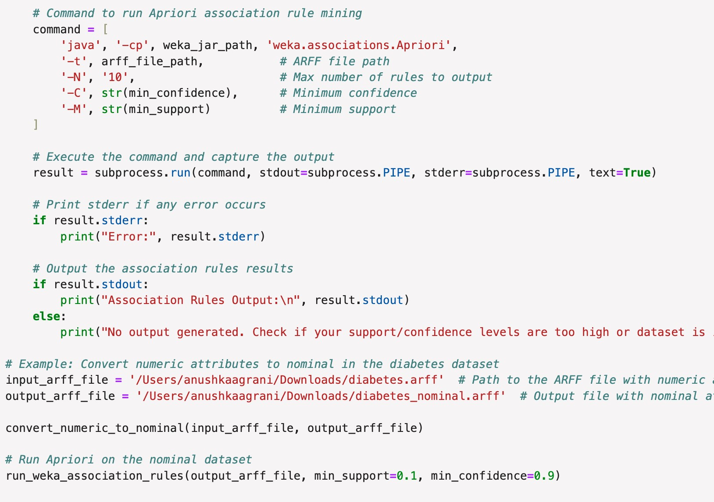

**OUTPUT:**

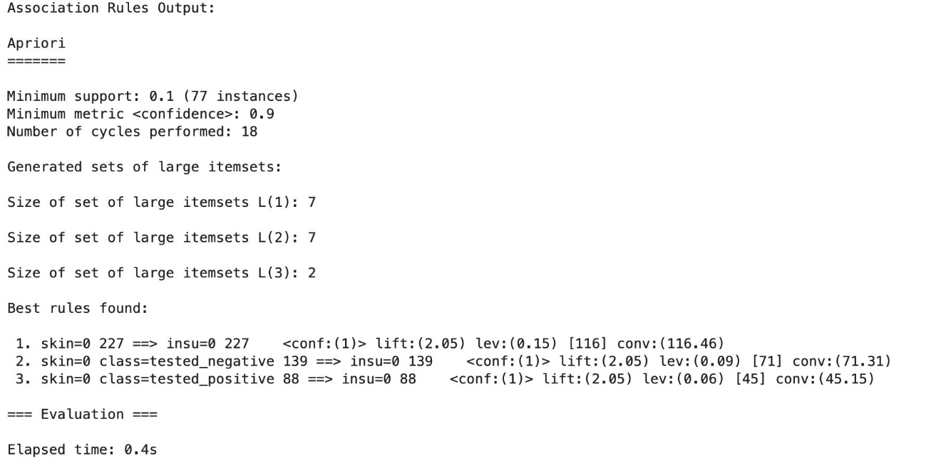

**EXPERIMENT - 8**

**AIM:** Implementation of Visualization Technique on ARFF Files using WEKA

**THEORY:**

Visualization in WEKA involves the graphical representation of data to help users better understand patterns, relationships, and insights in the dataset. WEKA provides a variety of visualization tools for different tasks, such as plotting attribute distributions, visualizing cluster assignments, or evaluating classification results. When working with ARFF (Attribute-Relation File Format) files, WEKA can display scatter plots, bar charts, and other types of graphs that enable users to visually explore data features, distributions, and model outputs. Visualization is especially helpful for understanding data distributions, detecting outliers, and identifying trends, which can guide further analysis and model development**.**

**SOURCE CODE:**

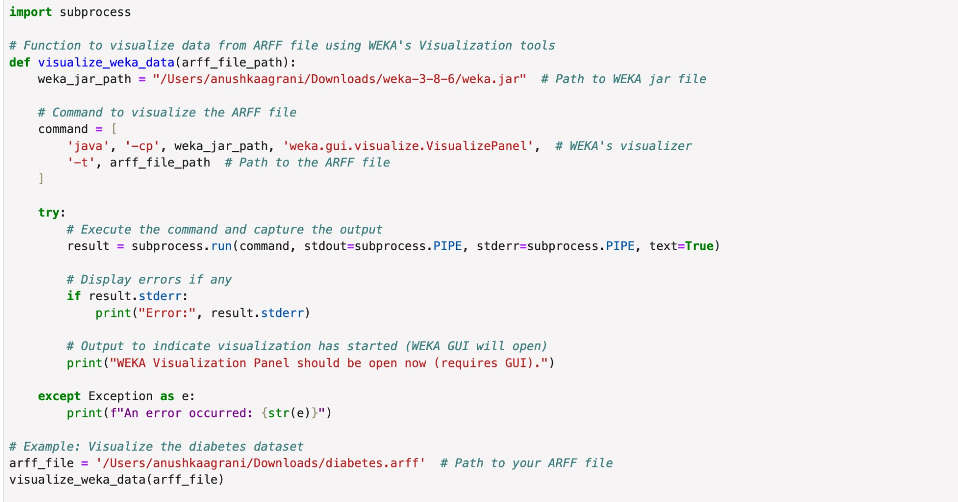

**OUTPUT:**

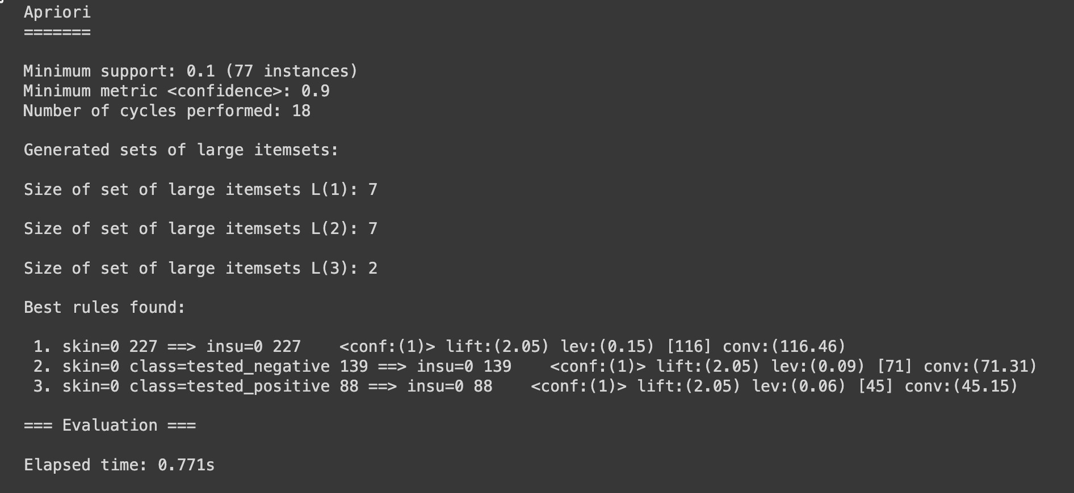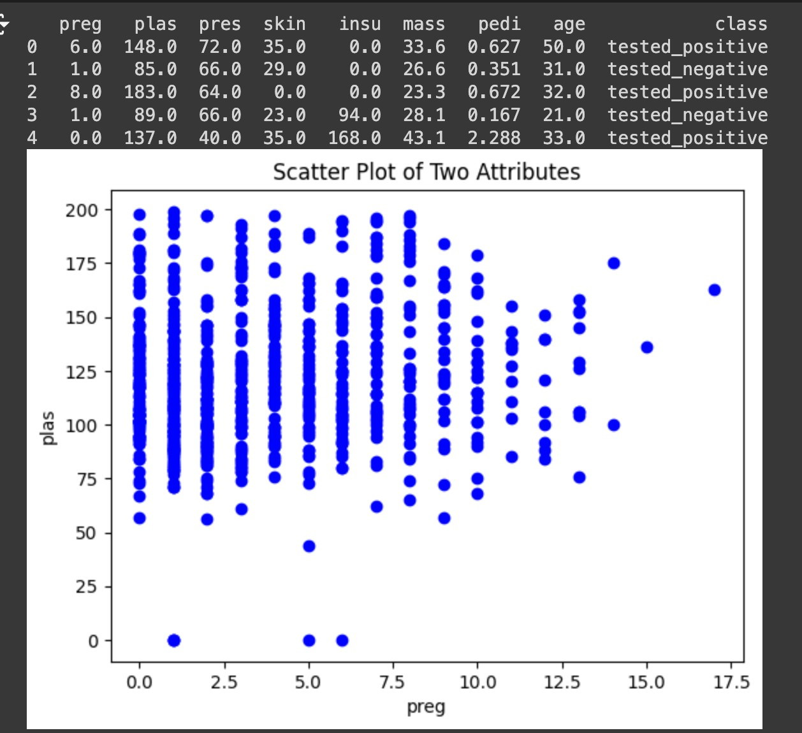

**EXPERIMENT - 9**

**AIM:** Perform Data Similarity Measure (Euclidean, Manhattan Distance).

**THEORY:**

Data similarity measures are used to quantify the degree of similarity or dissimilarity between data points in a dataset. In machine learning and data analysis, distance metrics like Euclidean and Manhattan distances are commonly used to compute how close or far two points are from each other in a multidimensional space. These measures are fundamental in clustering, classification, and nearest-neighbor algorithms.

1. **Euclidean Distance**

The Euclidean distance is the most common measure of similarity between two points in a Cartesian plane. It represents the "straight-line" or "as-the-crow-flies" distance between two points. This metric works well when the relationship between the attributes follows a straight-line distance (i.e., when the differences between values are proportional). It is sensitive to differences in magnitude, so scaling or normalizing the data may be necessary before applying this measure.

1. **Manhattan Distance (Taxicab or City Block Distance)**

The Manhattan distance, also called taxicab distance or L1 norm, calculates the distance between two points along the axes at right angles. Instead of a straight-line distance, it measures how far apart the points are if you had to travel along grid lines. This metric is useful when the attributes or features have distinct differences that should be treated additively. It is more robust to outliers than Euclidean distance, as it does not square the differences.

These distance metrics help to quantify the relationship between data points, allowing algorithms to group similar points together, classify new points, or explore data structure based on distance.

**SOURCE CODE:**

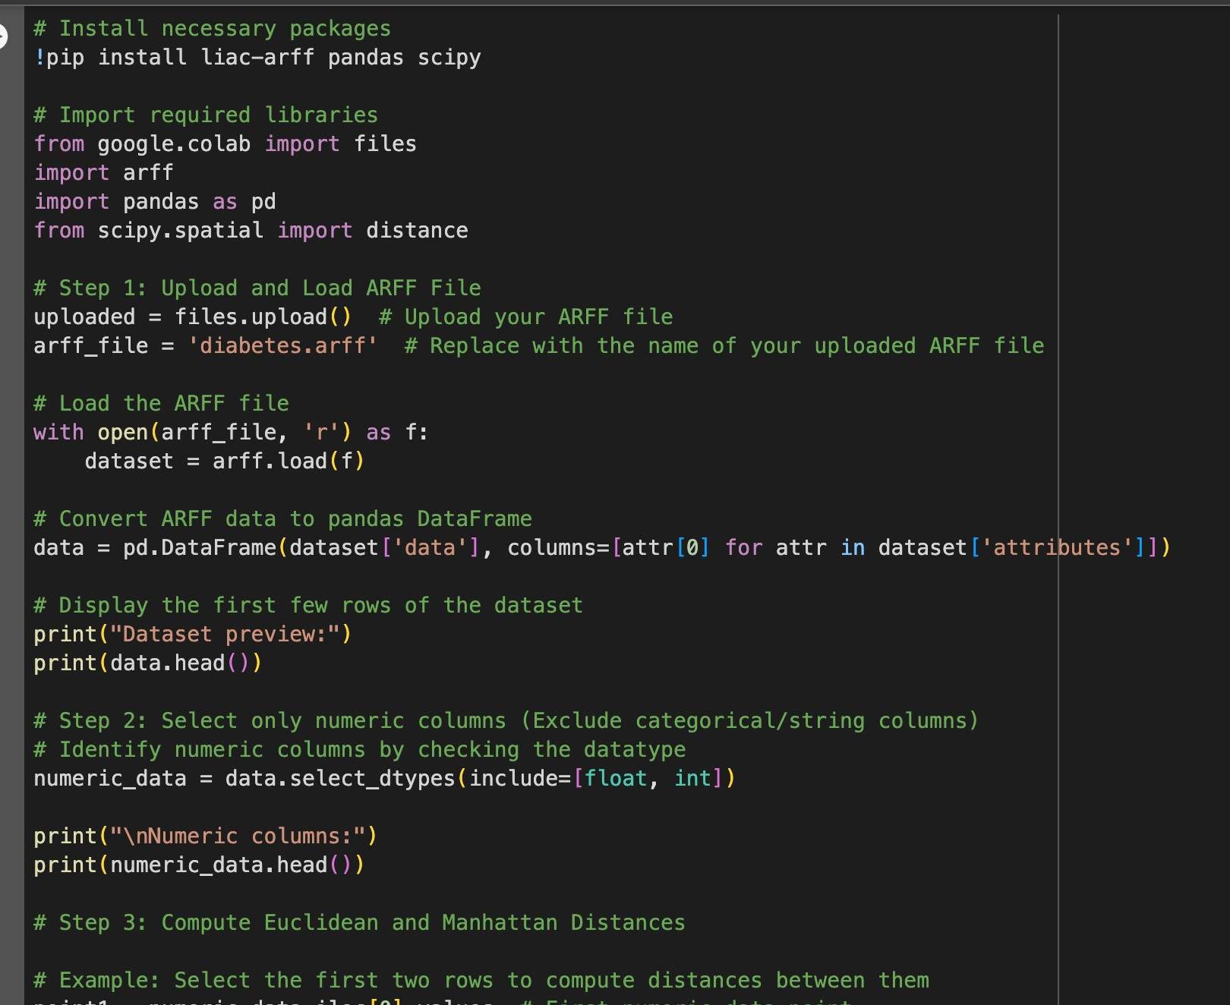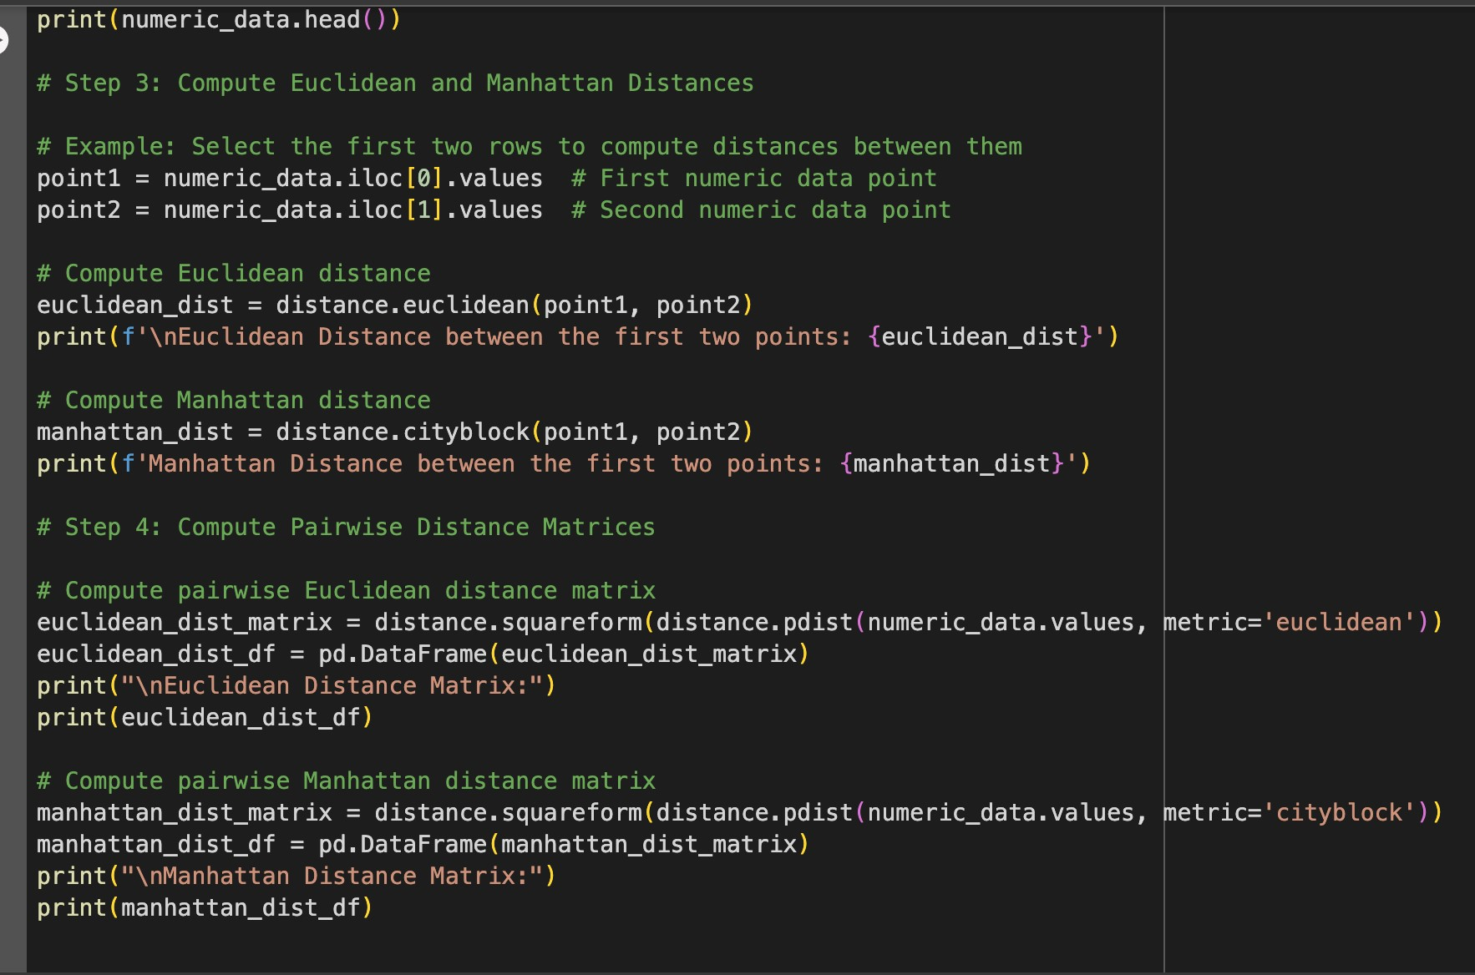

**OUTPUT:**

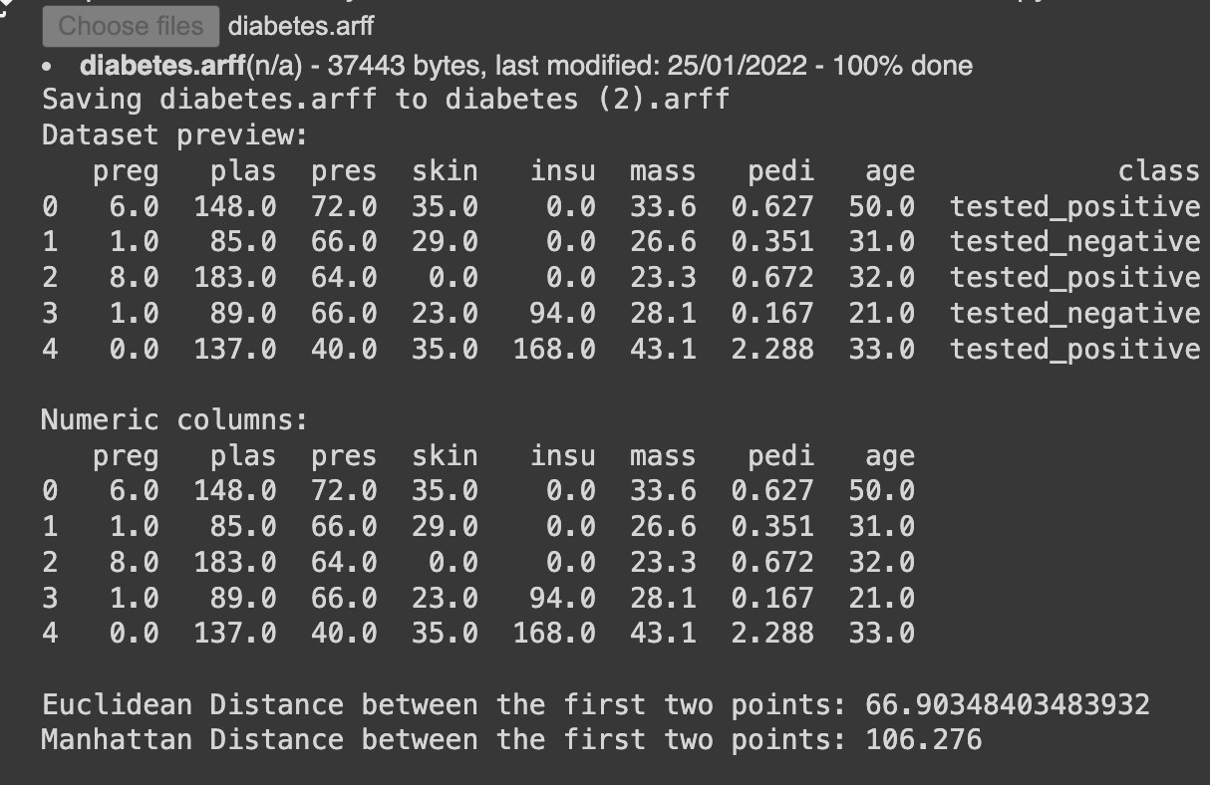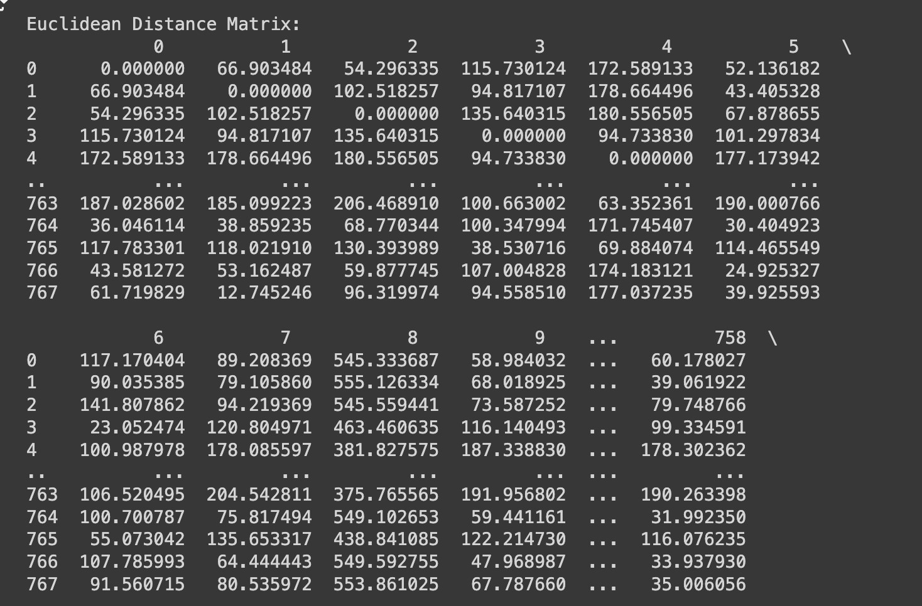

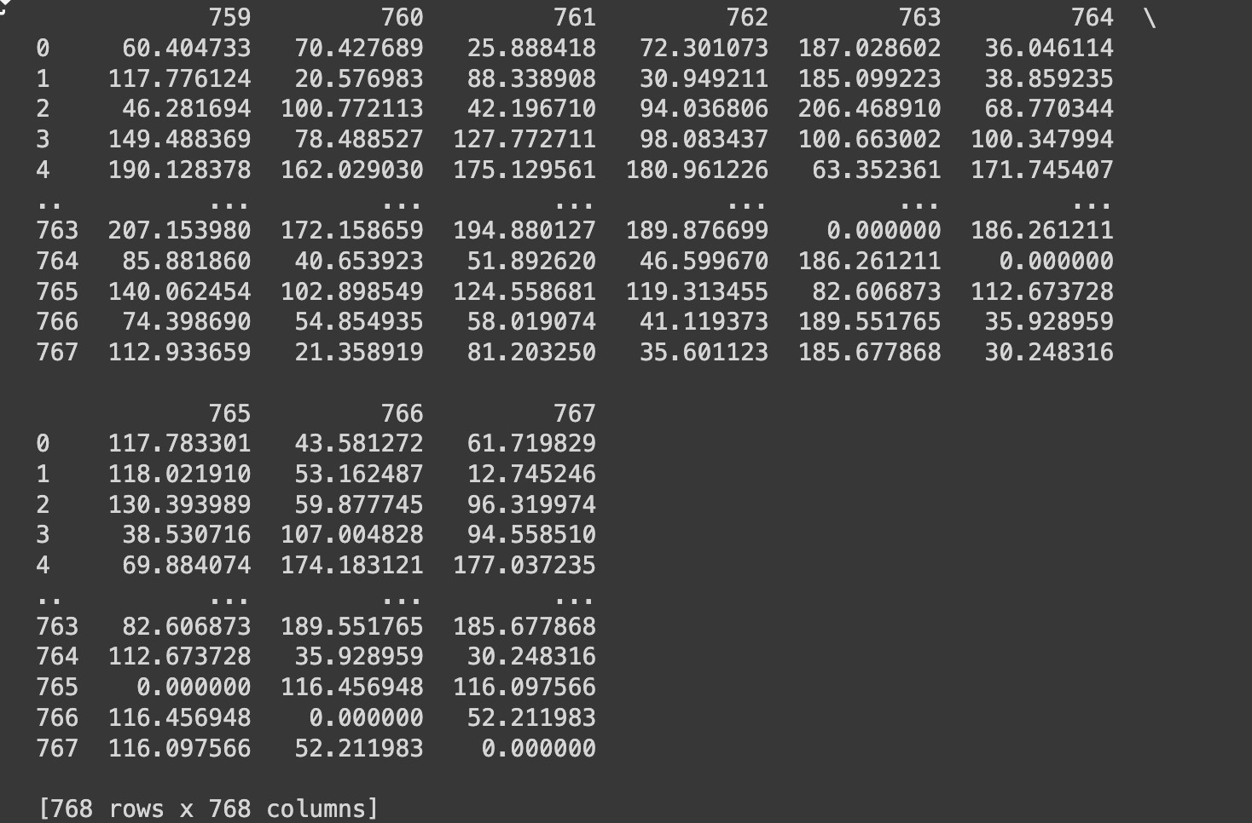

**EXPERIMENT – 10**

**AIM:** Perform Apriori algorithm mine frequent item-sets.

**THEORY:**

The Apriori algorithm is one of the most widely used algorithms in association rule mining to discover frequent item-sets in a dataset and generate strong association rules. It was introduced by Rakesh Agrawal and Ramakrishnan Srikant in 1994, and it works by identifying frequent individual items in the dataset and extending them to larger item-sets only if those item-sets appear sufficiently often.

The goal of Apriori is to find relationships between items in a large dataset, such as in market basket analysis, where it identifies products that are frequently bought together. It is particularly useful for finding correlations, patterns, and rules in transaction datasets.

**SOURCE CODE:**

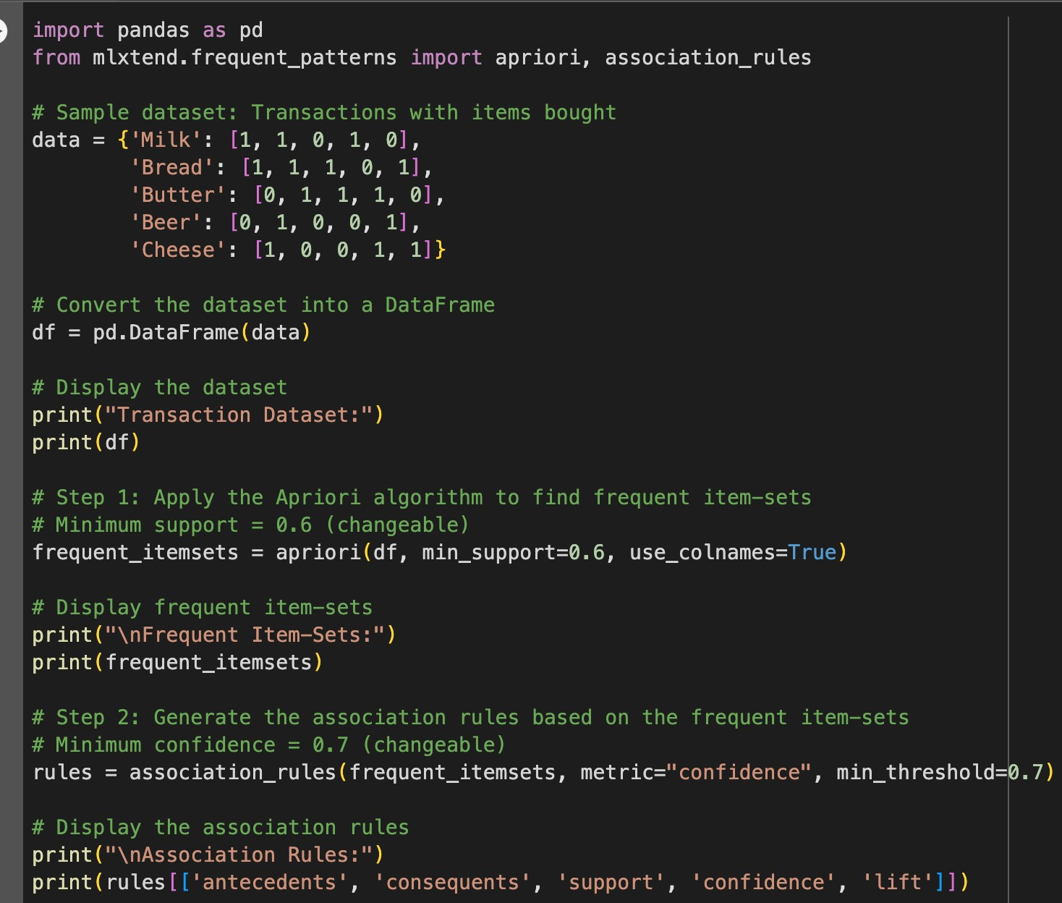

**OUTPUT:**

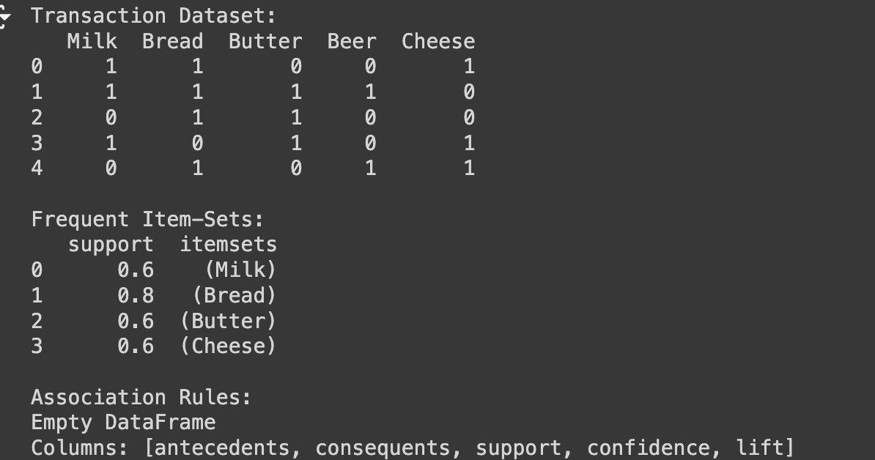

**EXPERIMENT - 11**

**AIM:** Develop different clustering algorithms like K-Means, KMedoids Algorithm, Partitioning Algorithm and Hierarchical

**THEORY:**

Clustering algorithms, such as K-Means, K-Medoids (PAM), and Hierarchical Clustering, are essential techniques in unsupervised learning used to group similar data points based on their features. K-Means partitions data into K clusters by minimizing the variance within clusters and is fast but sensitive to outliers. K-Medoids (PAM), similar to K-Means, selects actual data points as medoids and is more robust to noise and outliers. Hierarchical Clustering builds a hierarchy of clusters, represented by a dendrogram, and doesn’t require pre-specifying the number of clusters. Each algorithm has unique strengths: K-Means is efficient for large datasets, K-Medoids handles outliers better, and Hierarchical Clustering provides a tree-like structure for visualizing nested clusters. The choice of algorithm depends on the dataset, the nature of the clusters, and the need for handling outliers or non-spherical clusters.

**SOURCE CODE:**

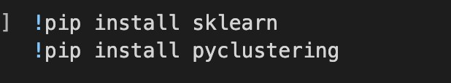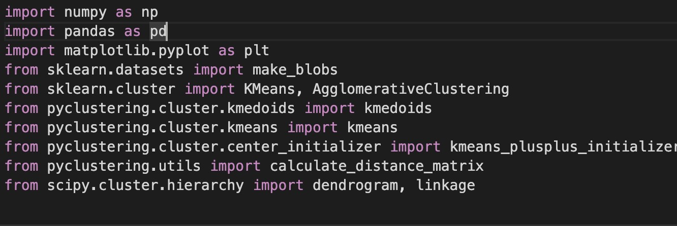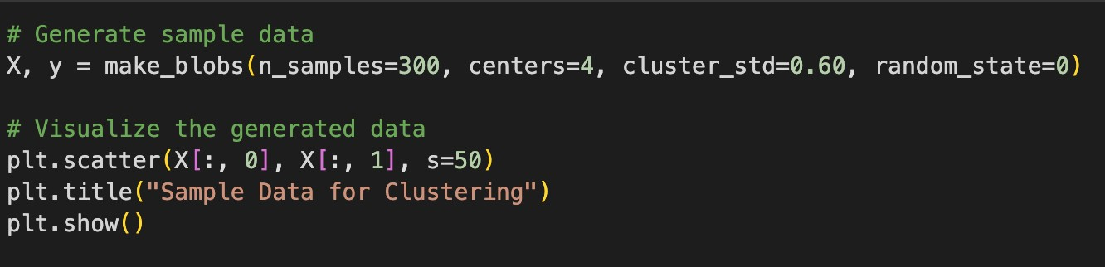

**KMEANS:**

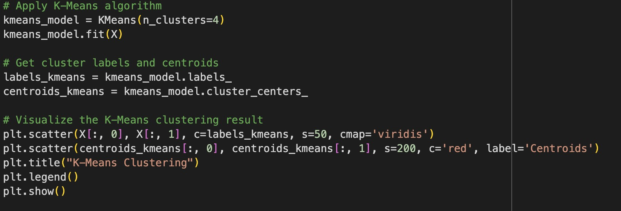

**K-MEDOIDS:**

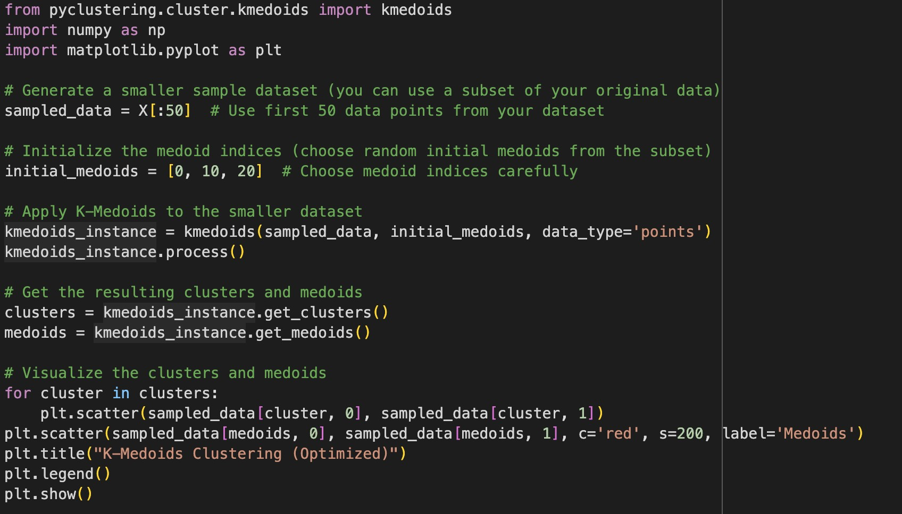

**PAM:**

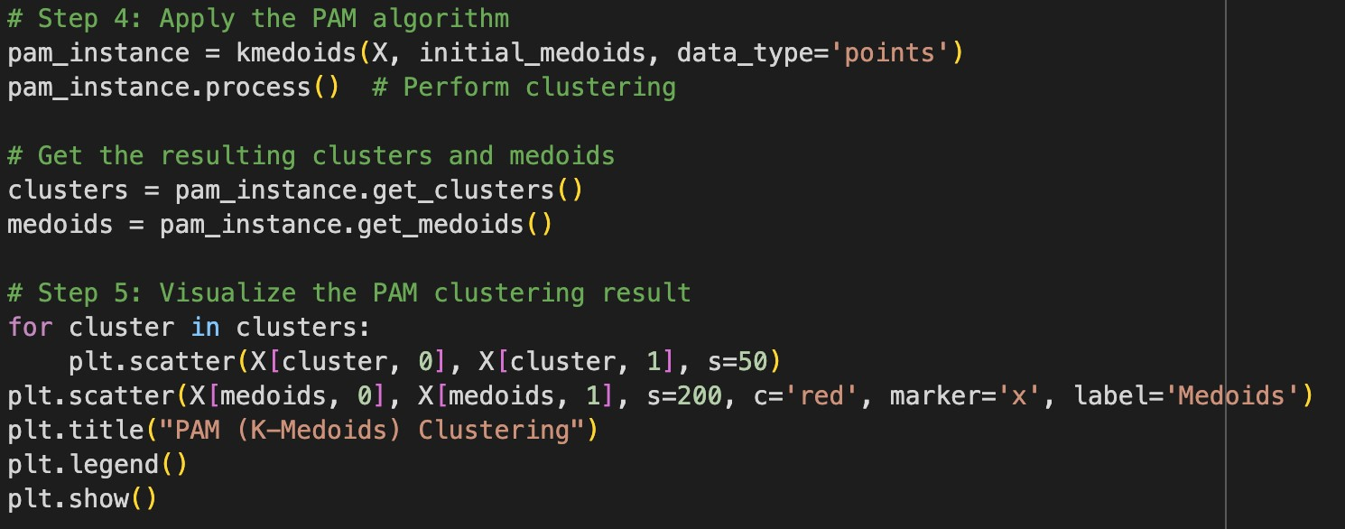

**HIERARCHAL:**

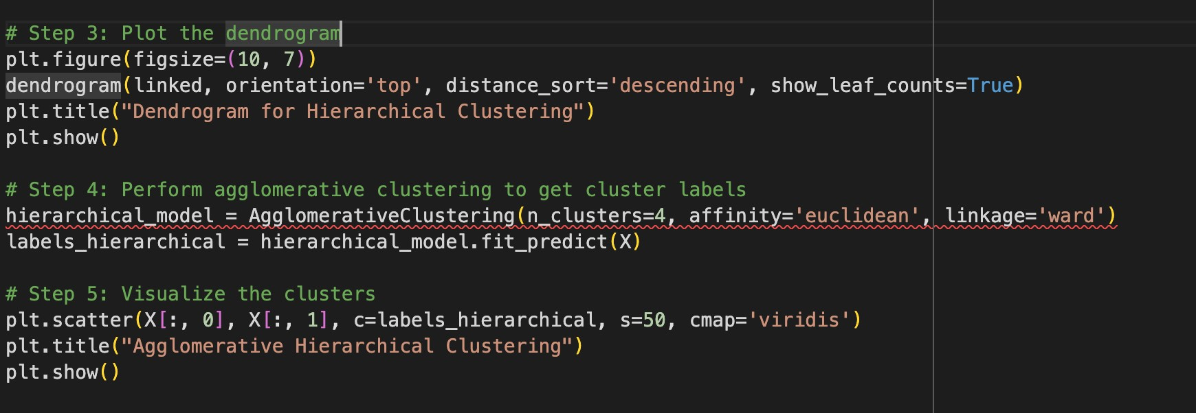

**OUTPUT:**

**VISUALIZATION OF DATA:**

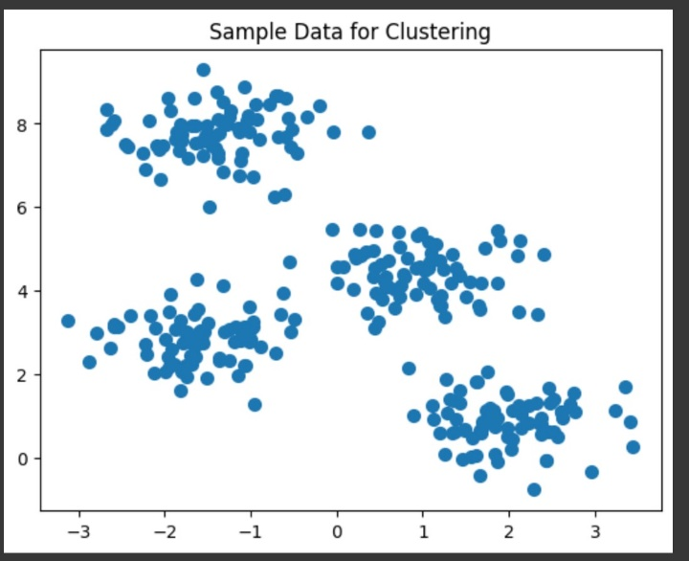

**KMEANS:**

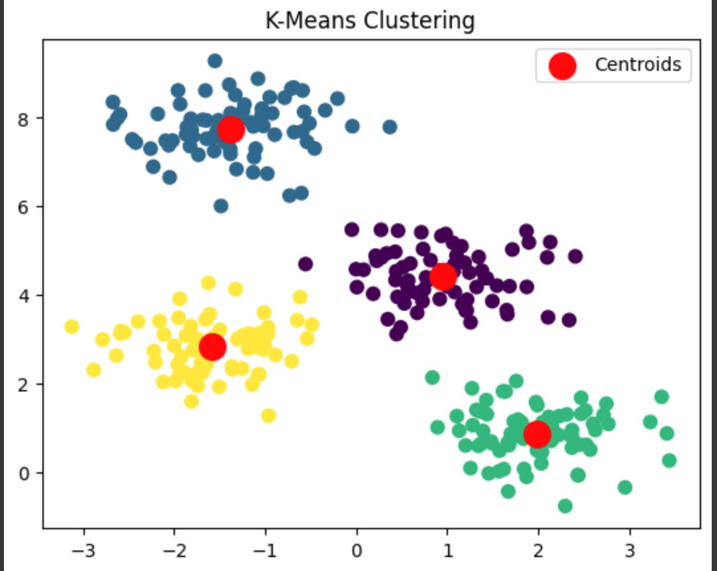

**K-MEDOIDS:**

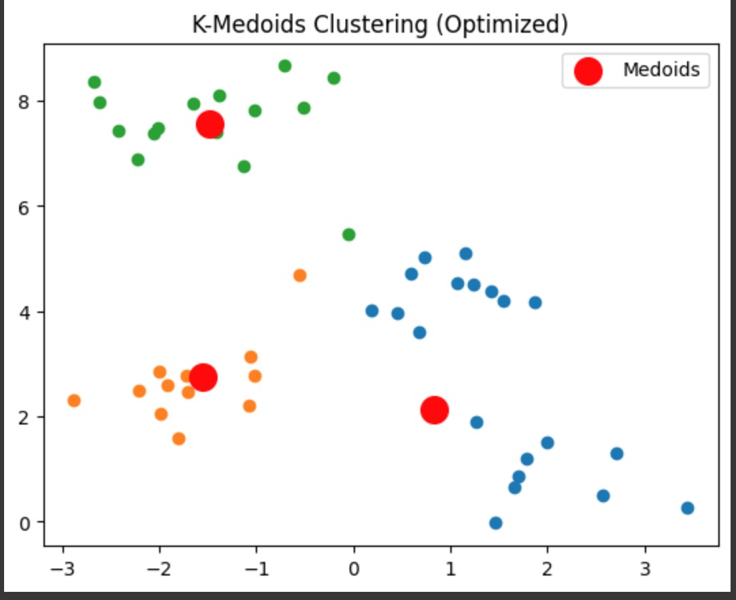

**PAM:**

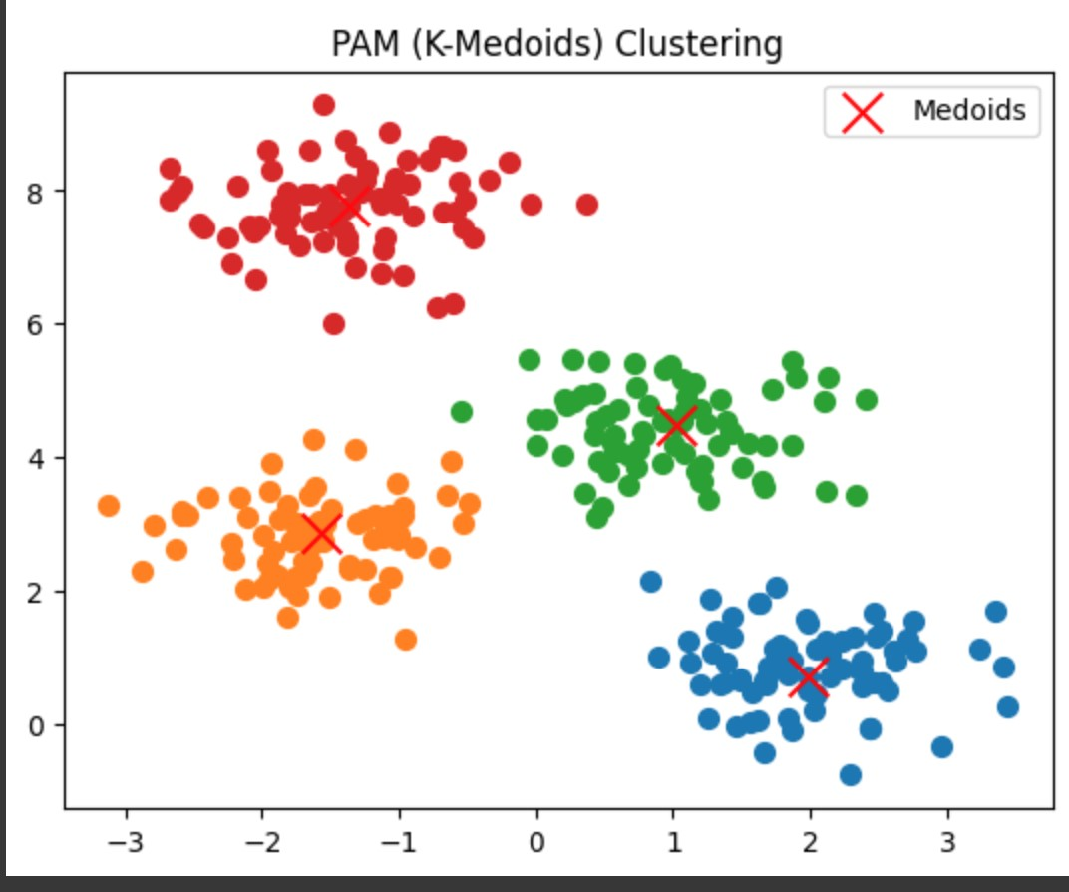

**HIERARCHAL:**

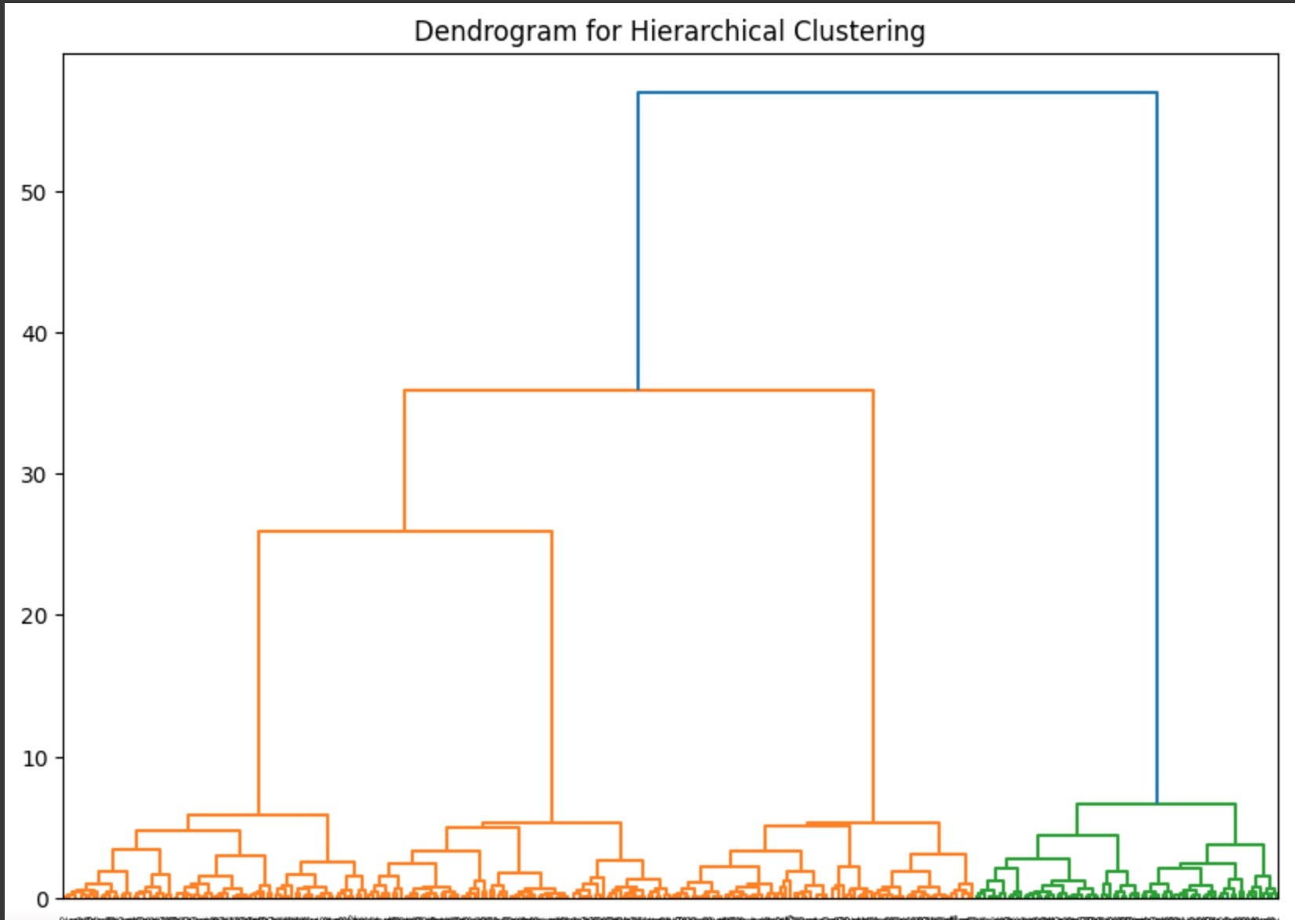

**EXPERIMENT 12**

**AIM:** Apply Validity Measures to evaluate the quality of Data

**THEORY:**

* Missing Values: Missing data can introduce bias or lead to errors in training a model.
* Outliers: Outliers can distort models and reduce the overall quality of the dataset.
* Multicollinearity: Highly correlated features (multicollinearity) can degrade model performance.
* Feature Distribution: Checking for skewness helps in identifying transformations needed.
* Class Imbalance: Imbalanced datasets can lead to biased models in classification tasks.

**SOURCE CODE:**

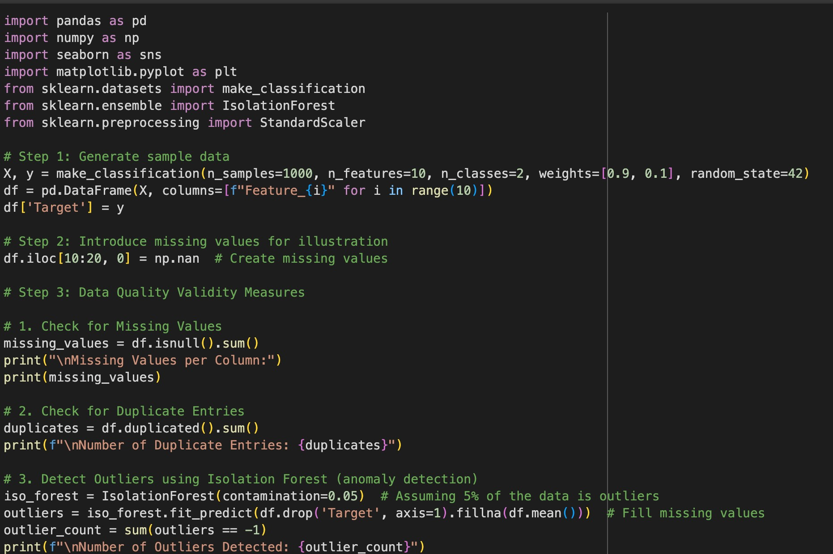

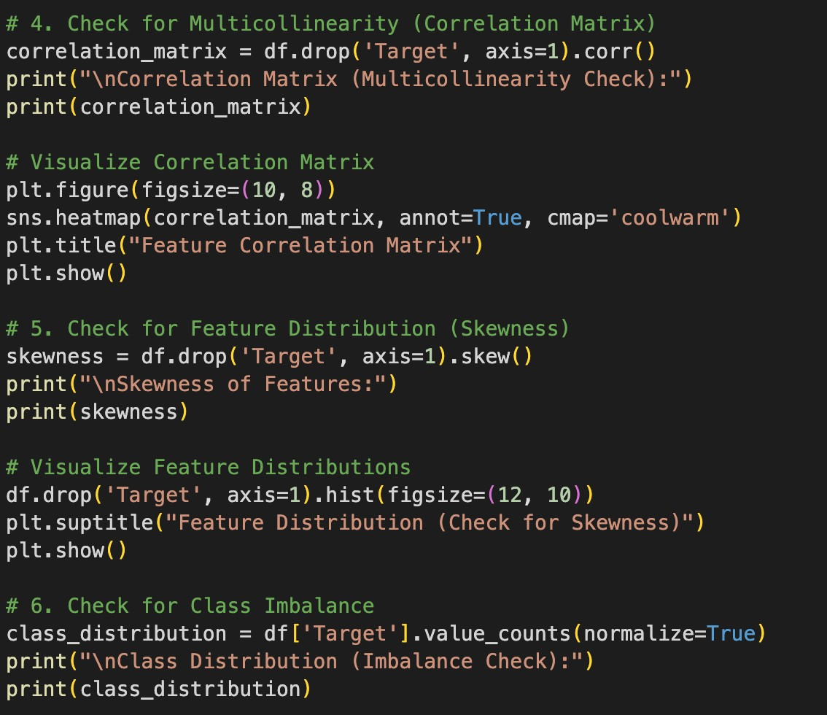

**OUTPUT:**

